Technical Datasheet Input / Output Modules with Modbus RTU Protocol with RS485 Interface

The IO modules communicate via RS485. The port can drive distances up to max 700 meters without the use of any repeater (this feature however also depends on the signal strength of the Modbus Master Device).
The RS485 Digital IO module is sturdy, low power usage and easy to use.

8 Port DI and 8 Port DO Module:-
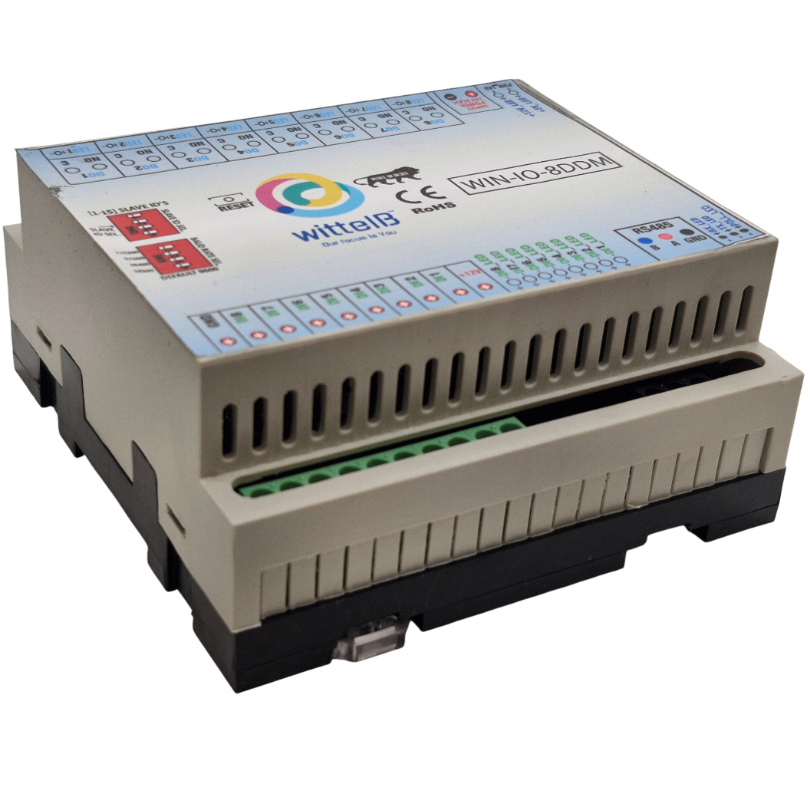
The IO modules are mounted on DIN rail mountable casing and with exposed connectors and LED indicators. The DIP switch for Slave ID and Baud rate are placed inside the enclosure.
The design of the modules incorporates ‘resettable Fuses’ to safeguard against sudden High Voltage spikes. The board also has ‘reverse polarity’ protection both for input Power connector
The communication port also has signal isolation and additional Jumper for ‘end of line’ 120 ohms termination resistance which may or may not be used.
Specifications

General:-
I/O Connectors | 12 Pin 5.08 mm and 2 Pin 5.08 mm pitch pluggable screw terminal block
Dimensions | 110 mm L × 110 mm B × 50 mm H
Power | Input Power: 9–36 V DC or 24 V AC/DC Typical: 12 V DC @ 1 A
Operating Temperature | 0 – 60° C (32 ~ 140°F)
Storage Temperature | -20 - 70° C (-4 ~ 158°F)
Storage Humidity | 5 ~ 95 % RH, non – Condensing
Certifications | 

NOTE:-
Without Load : ~69 mA @ 12 VDC
With Full Load: ~300 mA @ 12 VDC(8 relays ON)
Relay Output:-
Channels | 8
Contact Form | 1A, 1C
Contact Material | Ag Alloy
Contact Capacity | 10A @ 240VAC, 10A @ 28VDC
Coil Voltage | 5 – 12 VDC
Coil Power | 0.36 W
Insulation Resistance | 250MΩ
Electrical Life | 1 x 10^5
Mechanical Life | 1 x 10^7
Operating Time | 7 msec, Max 15 msec
Release Time | 2 msec, Max 6 msec
DI Inputs:-  Channels | 8
Sense Voltage | 3.3 – 30 VDC
Sense Logic | Logic ‘0’ = <1 VDC, Logic ‘1’ = >3.3 VDC
Isolation | Optically isolated
Response Time | 2 msec, Max 6 msec
Additional Features:-
All inputs and communication port isolated
Input power reverse polarity safety
ESD Safety IEC 61000-4-2, ± 30KV contact, ± 30KV air
EFT IEC 61000-4-4, 50A (5/50ms)
400V isolation.
CRC Error check.
No configuration needed on the IO board

DIP SETTING – For Manual Switch Setup

Configuration Settings:-

Communication Speed 9600 - 115200(DIP SW selectable)
Data Bits | 8
Parity | None
Stop bit | 1
CRC | Yes
Slave ID | 1 – 15 (DIP SW selectable)
Function code DO | 0x05 and 0x0F (5 Single coil & 15 multiple coil)
DO Register Address | 0,1,2,3,4,5,6,7.
Function code DI | 0x02 Read Discrete Input
DI Register Address | 8,9,10,11,12,13,14,15.

Recommended Cable Electrical Characteristics:-
22 AWG Cable | Shielded and twisted pair
Tinned Copper | Recommended
Nominal Conductor DCR | 14.7 ohm / 1000 ft
Nominal Capacitance | 11 pf / feet (conductor to conductor)
High Frequency Non-Insertion Loss | 0.5 db / 100 ft

Note:-
For MODBUS communications, a shielded and twisted pair cable is used. One example of such cable is Belden 3105A.
BAUD RATE DESRIPTION:-

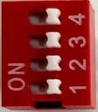

L
SB

M
SB

- For Baud rate Selection, DIP SW is used as per the diagram.
- Pulling up the switch will make Baud rate active.
- If no selection is made 9600 will be default Baud rate.
- When you change the Baud rate in the Module power ‘ON’ condition, please press the reset button to get Change to affect.
Baud Rate | DIP SWITCH
 | 1 | 2 | 3 | 4
9600 | OFF | OFF | OFF | OFF
19200 | OFF | OFF | OFF | ON
38400 | OFF | OFF | ON | OFF
57600 | OFF | ON | OFF | OFF
115200 | ON | OFF | OFF | OFF

SLAVE ID DESCRIPTION:-



MSB

LSB

- For Slave ID Selection SW is used to Set The SLAVE ID .
- For Slave ID DIP Switch LSB is “1” follow through “4” is MSB.
- Slave ID Confirmed through below Device ID table .
- IF Eg. Slave ID 1 is Needed to be selected Switch number 1 should pulled up other three should be selected down side. So”1 0 0 0” will be selected as Slave ID 1.
Slave ID |  | DIP SWITCH |  |  | OUTPUT  (Binary) | OUTPUT  (Decimal)
 | 1 | 2 | 3 | 4
0 | OFF(0) | OFF(0) | OFF(0) | OFF(0) | 1 0 0 0 | 1
1 | ON(1) | OFF(0) | OFF(0) | OFF(0) | 1 0 0 0 | 1
2 | OFF(0) | ON(1) | OFF(0) | OFF(0) | 0 1 0 0 | 2
3 | ON(1) | ON(1) | OFF(0) | OFF(0) | 1 1 0 0 | 3
4 | OFF(0) | OFF(0) | ON(1) | OFF(0) | 0 0 1 0 | 4
5 | ON(1) | OFF(0) | ON(1) | OFF(0) | 1 0 1 0 | 5
6 | OFF(0) | ON(1) | ON(1) | OFF(0) | 0 1 1 0 | 6
7 | ON(1) | ON(1) | ON(1) | OFF(0) | 1 1 1 0 | 7
8 | OFF(0) | OFF(0) | OFF(0) | ON(1) | 1 0 0 0 | 8
9 | ON(1) | OFF(0) | OFF(0) | ON(1) | 1 0 0 1 | 9
10 | OFF(0) | ON(1) | OFF(0) | ON(1) | 1 0 1 0 | 10
11 | ON(1) | OFF(0) | ON(1) | ON(1) | 1 0 1 1 | 11
12 | OFF(0) | OFF(0) | ON(1) | ON(1) | 1 1 0 0 | 12
13 | ON(1) | OFF(0) | ON(1) | ON(1) | 1 1 0 1 | 13
14 | OFF(0) | ON(1) | ON(1) | ON(1) | 1 1 1 0 | 14
15 | ON(1) | ON(1) | ON(1) | ON(1) | 1 1 1 1 | 15

SOFT SETTING – For Modbus / Software Setup

Configuration Settings:-
Communication Speed 9600 – 115200.
Data Bits | 8
Parity | None
Stop bit | 1
CRC | Yes
Slave ID | Soft Setting(0-247).
Function code DO | 0x05 and 0x0F (5 Single coil & 15 multiple coil)
DO Register Address | 0,1,2,3,4,5,6,7.
Function code DI | 0x02 Read Discrete Input
Function code Soft Serial 0x03 Read Holdings Register
DI Register Address 8,9,10,11,12,13,14,15.
Soft Serial Register Address 11, 12,13,14,15,16,17,18.

Note:-

- In register 40015- you will able to see the current parity and you can change it in register 40016
- In register 40017- you will able to see the current stop bit and you can change it in register 40018
- If you want to enter the baud rate 9600/19200/38400/57600/115200etc.Enter it as 960/1920/5760/11520etc.
- After that press the reset button or reboot the system.

ID | Function Description | Register Description | Modbus Function Code | Protocol | Data Type
0 | DO 1 | 00001 | 0X05,0X0F | RS485 | 1 Bit Boolean
1 | DO 2 | 00002 | 0X05,0X0F | RS485 | 1 Bit Boolean
2 | DO 3 | 00003 | 0X05,0X0F | RS485 | 1 Bit Boolean
3 | DO 4 | 00004 | 0X05,0X0F | RS485 | 1 Bit Boolean
4 | DO 5 | 00005 | 0X05,0X0F | RS485 | 1 Bit Boolean
5 | DO 6 | 00006 | 0X05,0X0F | RS485 | 1 Bit Boolean
6 | DO 7 | 00007 | 0X05,0X0F | RS485 | 1 Bit Boolean
7 | DO 8 | 00008 | 0X05,0X0F | RS485 | 1 Bit Boolean
8 | DI 1(With & Without Potential) | 00009 | 0X02 | RS485 | 1 Bit Boolean
9 | DI 2(With & Without Potential) | 00010 | 0X02 | RS485 | 1 Bit Boolean
10 | DI 3(With & Without Potential) | 00011 | 0X02 | RS485 | 1 Bit Boolean
11 | DI 4(With & Without Potential) | 00012 | 0X02 | RS485 | 1 Bit Boolean
12 | DI 5(With & Without Potential) | 00013 | 0X02 | RS485 | 1 Bit Boolean
13 | DI 6(With & Without Potential) | 00014 | 0X02 | RS485 | 1 Bit Boolean
14 | DI 7(With & Without Potential) | 00015 | 0X02 | RS485 | 1 Bit Boolean
15 | DI 8(With & Without Potential) | 00016 | 0X02 | RS485 | 1 Bit Boolean
10 | Display Baud Rate (Default:960) | 40011 | 0X03 | RS485 | 16 Bit Unsigned int
11 | Enter New Baud Rate | 40012 | 0X03 | RS485 | 16 Bit Unsigned int
12 | Display Slave ID (Default:1) | 40013 | 0X03 | RS485 | 16 Bit Unsigned int
13 | Enter New Slave ID | 40014 | 0X03 | RS485 | 16 Bit Unsigned int
14 | Display Parity (Default: None-3 And Odd-1,Even-2) | 40015 | 0X03 | RS485 | 16 Bit Unsigned int
15 | Enter New Parity | 40016 | 0X03 | RS485 | 16 Bit Unsigned int
16 | Display Stop Bit (start-2/stop bit-1) | 40017 | 0X03 | RS485 | 16 Bit Unsigned int
17 | Enter New Start/ Stop Bit. | 40018 | 0X03 | RS485 | 16 Bit Unsigned int

BAUD RATE and SLAVE ID DESCRIPTION:-
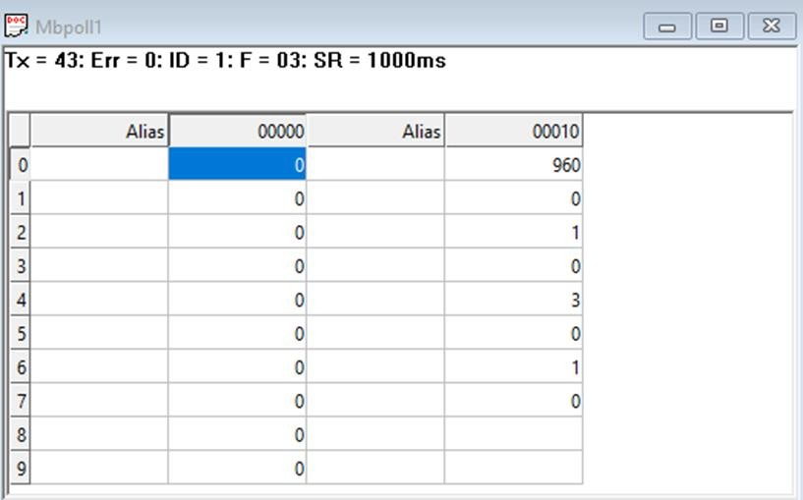

  - As you can see in the image above, the resistor 40011 – 960 represents the present bund rate (9600) of the board and 40013 – 1 represents the present slave id of the board.
  - To change the baud rate and slave id you have to enter a value on the 40012 resistor for the baud rate and 40014 for the slave id as shown in the image below.
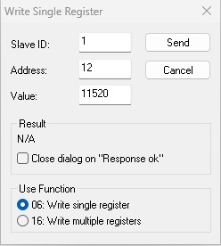
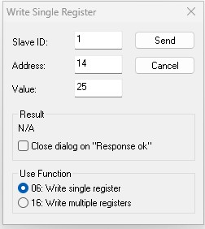

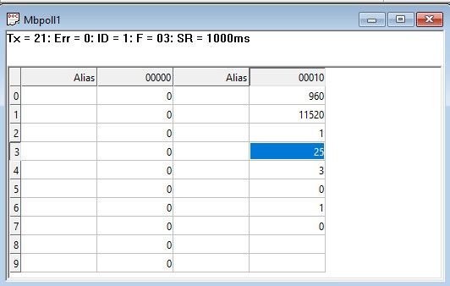

As you can see in the image above I set 115200 baud rate and slave ID 25.
Note:-
- When entering baud rate values such as 9600 / 19200 / 38400 / 57600 / 115200,enter them as 960 / 1920 / 3840 / 5760 / 11520, respectively.
- After entering the values, press the reset button or reboot the system.
- Once restarted, you will see the updated values:
- 40011 – 11520 → Baud Rate (115200)
- 40013 – 25 → Slave ID (25)
- You can also change Parity Bit and Stop Bit of the device in the same way.
- Jumper Setting (Hardware Method):
- If you place the jumper, the device will load its default communication settings (default baud rate(9600) and slave ID(1)).
- This is useful when you have many devices with different settings and want a quick way to restore defaults without software changes.
- Relation between Jumper and Reset Button:
The jumper enables the default mode, and the reset button activates it.
- Simply insert the jumper → press reset → the device restarts with factory default settings automatically.

DI
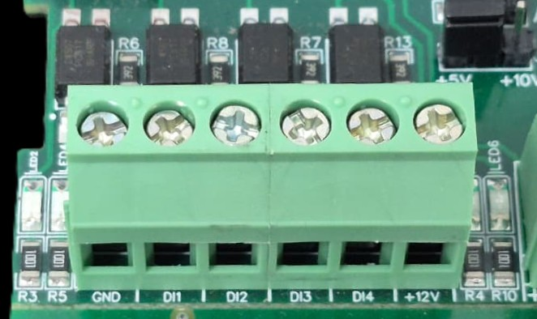
I/p device
I/p device
I/p device
I/p device

- Operation: The module provides four isolated input channels (DI1–DI4) for sensing external signals or dry contacts. These inputs are opto-isolated for circuit protection.
- Terminal Layout:
  - GND: Common Ground reference.
  - DI1 – DI4: Individual Digital Input channels.
  - +12V: Internal reference voltage for sourcing "Dry Contact" switches.
- Wiring Options:
  - Dry Contact: Connect a switch between the +12V terminal and any DI pin.
  - External Voltage: Connect the external signal to a DI pin and the external ground to the GND terminal.
- Voltage Rating: The input circuitry is rated for a maximum of 80VDC. Ensure external signals do not exceed this limit to prevent damage to the isolation ICs.

DO

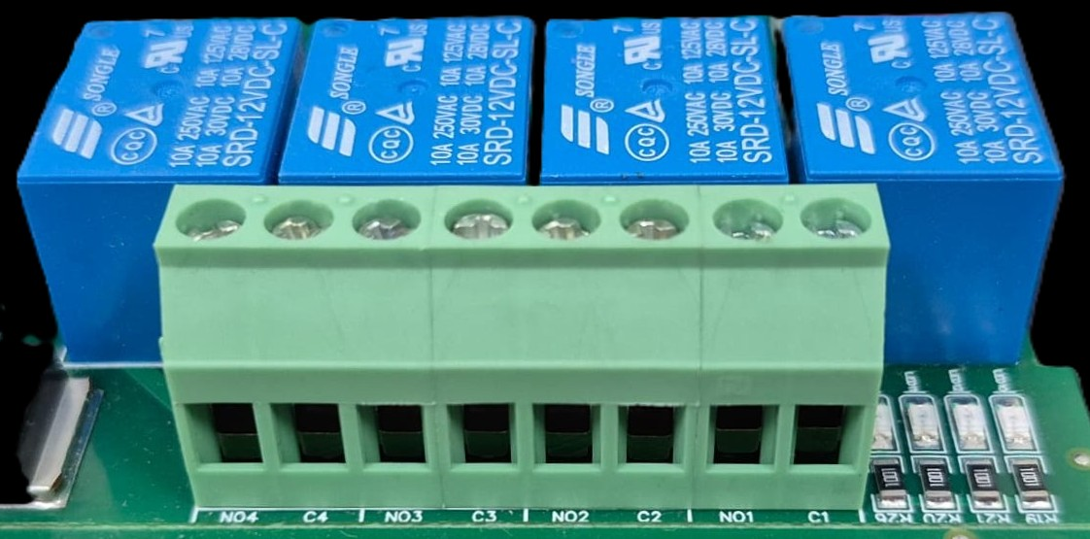





L
O
A
D
N

P
L
O
A
D
N

P
L
O
A
D
N

P
L
O
A
D
N

P

- Digital Output (DO) operation: Each channel provides two terminals: C (Common) and NO (Normally Open). When the relay coil is energized, terminal C is internally connected to NO, allowing current to flow. When the relay is de-energized, the connection between C and NO remains open, and the load stays OFF.
- Load Wiring Connections:
  - AC Load Connection: The AC Live (Phase) wire should be connected to terminal C. The load is connected between terminal NO and Neutral (N).
  - DC Load Connection: The positive supply (+V) should be connected to terminal C. The load is connected between terminal NO and Ground (GND).
- Crucial Safety Recommendation and Rating: It is strongly recommended to switch the Live (Phase) conductor in AC applications to ensure the load is safely de-energized when the relay is off.
Note: Ensure that the connected load does not exceed the relay’s contact rating of 10A @ 250VAC (or 10A @ 125VAC) or 10A @ 30VDC (or 10A @ 28VDC).

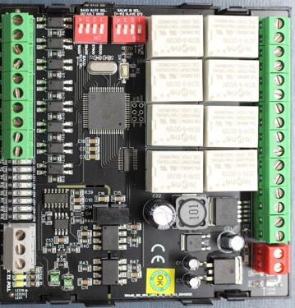
Reset Button

DI Ports

1

2

3

45

5

6

72

81

Common
GND

+12
V

Ref
e
re
nce

MSB

LSB

LSB

MSB

Modbus
RS485

Input
9
-
36

VDC

Baud
Rate

Slave
ID

8

7

6

5

4

3

2

1

DO Ports

–

NO contacts

Contact us:-
Augmatic Technologies Pvt. Ltd.,
Plot no 6, Shah Industrial Estate II,
Kotambi,
Vadodara – 391510.
Email – Sales@wittelb.com
Support: support@wittelb.raiseaticket.com / +91 94038 92805

